area-starter.rkt

**Signature, purpose, stub**

Signature



Purpose



Not a good purpose: 

* It just repeats the signature
* Must be more specific than the signature

Stub



**Examples**



* For now, have a wrong test (area 3) 3)

Run the program



Comment out stub and label



**Inventory**

Template



Copy, comment out and label

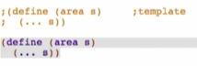

**Code body**



Run the program

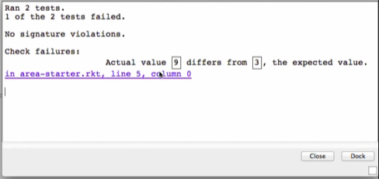

Click the link to see which test it is



Correct the test then rerun

 -> 

When a test fails, there are multiple scenarios:

1. The test is wrong – check this first before fixing the function definition!
2. The function definition is wrong
3. They are both wrong